
CONFIDENTIAL CS/NOV 2026/CSC429

UNIVERSITI TEKNOLOGI MARA FINAL EXAMINATION

COURSE
COURSE CODE
EXAMINATION TIME
COMPUTER ORGANIZATION AND ARCHITECTURE

CSC429
NOVEMBER 2026
3 HOURS

INSTRUCTIONS TO CANDIDATES

- This question paper consists of two (2) parts: PART A (10 Questions) PART B (1 Question)

- Answer ALL questions in the Answer Booklet. Start each answer on a new page.

- Do not bring any material into the examination room unless permission is given by the invigilator .
- Please check to make sure that this examination pack consists of: i) the Question Paper
  - an Answer Booklet - provided by the Faculty

- Answer ALL questions in English.

DO NOT TURN THIS PAGE UNTIL YOU ARE TOLD TO DO SO

This examination paper consists of 5 printed pages.

PART A (80 MARKS)
Answer ALL questions in this part.
QUESTION 1 (5 marks)
John von Neumann was credited with introducing the Von Neumann architecture, a
pioneering concept in computer design. Additionally, he contributed to the development of
the two's complement numbering system.
- What is the name of the machine that John Von Neumann himself invented?
- Why was the two's complement numbering system introduced?
- Name TWO (2) memory contents that are allowable in the Von Neumann architecture.
QUESTION 2 (5 marks)
The Difference Engine was a mechanical computer designed by Charles Babbage in the 19th
century. It was one of the earliest examples of a mechanical calculator, built to automatically
compute mathematical tables for naval navigation.
- What device was the successor of the Difference Engine?
- Describe the difference in function between the Difference Engine and Mechanical
Calculating Machine.
- Briefly explain the available technology that existed in the computer generation of
Difference Engine.
QUESTION 3 (5 marks)
Solve -4810 + 6810 using the sign and magnitude method. Show the complete
workflow.
- Calculate -9610 -1510 using the I's and 2s complement method. Show the complete
workflow.
QUESTION 4 (5 marks)
- Define cache.
- Differentiate between cache and main memory in term of the following characteristics:
- Price
- Memory size
- Access time
- Distance from Central Processing Unit (CPU)
QUESTION 5 (10 marks)
- Describe the function of each computer bus type.
- Discuss TWO (2) benefits of synchronous bus timing.
QUESTION 6 (10 marks)
- Given the architecture of Single Instruction, Single Data Stream (SISD) is in Figure 1, with
CU representing Control Unit, PU representing the Processing Unit, and MU representing
the Memory Unit. Draw the following multiple processor organization with an appropriate
label. Clearly show the Instruction Stream (IS) and Data Stream (DS).
- Multiple Instructions Multiple Data streams (MIMD) with shared memory,
- Multiple Instructions Multiple Data streams (MIMD) with distributed memory.
- Give ONE (1) example for the following multiple-processor organization.
- Multiple Instructions Multiple Data streams (MIMD) with shared memory,
- Multiple Instructions Multiple Data streams (MIMD) with distributed memory.
- Discuss ONE (1) advantage of using Multiple Instructions Multiple Data stream (MIMD)
with distributed memory.
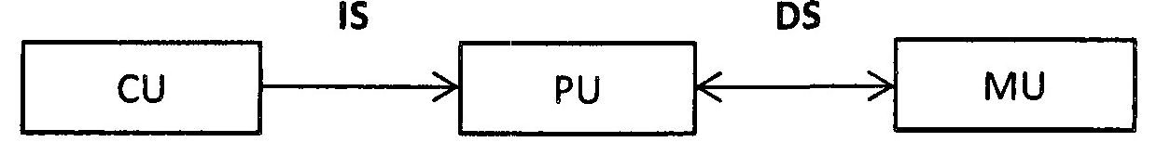
Figure 1: Single Instruction, Single Data Stream (SISD)
QUESTION 7 (10 marks)
- Why must the CPU be faster than all the other inpuuoutput devices?
- How do the l/O controllers facilitate communication between the CPU and l/O devices?
- Discuss TWO (2) types of l/O modules.
- When would an l/O controller of a specific device be installed?
QUESTION 8 (10 marks)
- Convert 123.687510 to floating point number in IEEE single precision format in
hexadecimal value form.
- Convert C24CC000H in IEEE single precision floating number to decimal value form.
QUESTION 9 (10 marks)
- Given the size of an address bus is 16 bit and the size of the data bus is 64 bit.
- Determine the size of data block. Give appropriate justification for such answer.
- What is the usage of address bus?
- What happens if a wider address bus is set?
- Discuss TWO (2) types of bus timing.
QUESTION 10 (10 marks)
Each generation is well known for its technology and machine invented. Complete the
following Table 1 with appropriate answers.
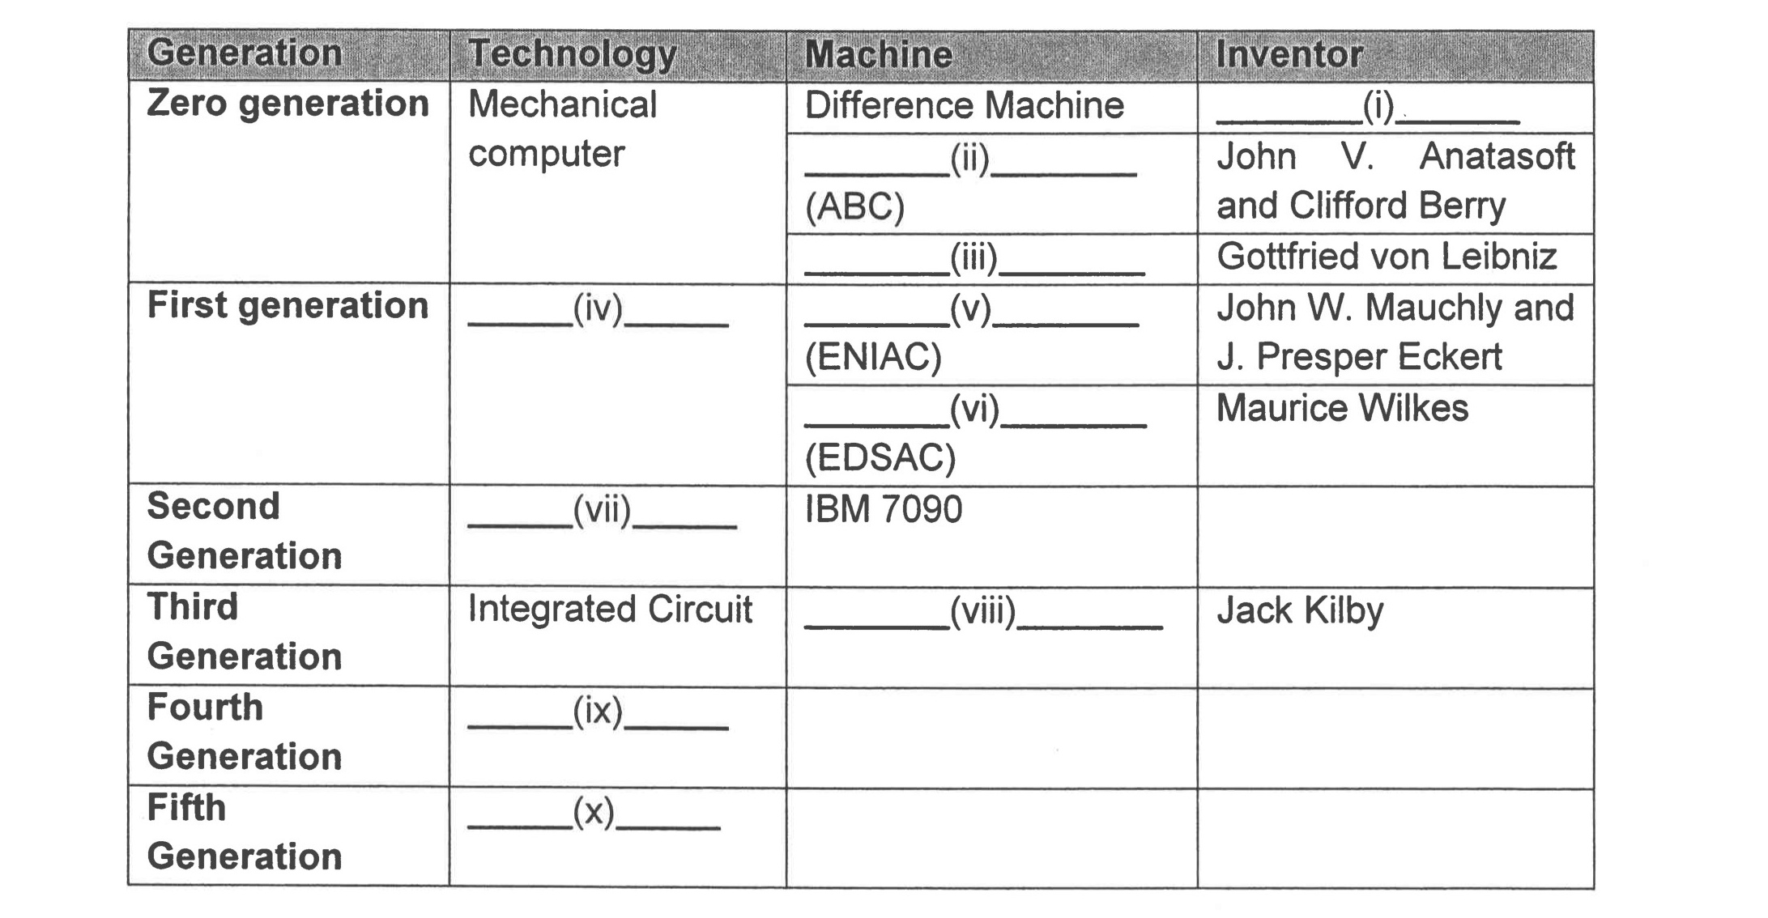
Table 1

PART B (20 MARKS)
Answer the question in this part.
QUESTION 11 (20 marks)
Question 1 is based on Figure 2 and Table 2.
Write an appropriate program using correct assembly language notations to compute the
equation shown in Figure 2 using instructions for one-address, two-address, and three-
address. The available instructions are provided in Table 2. The register labeled A, B, C, and
D are fixed, while registers x, y, and z can be used temporarily. The final answer must be
stored in register y.

Figure 2
Table 2 : Machine instruction
One-address | Two-address | Three-address
LOADp | MOV (p,q) | ADD (p.q.r)
STORp | ADD (p,q) | SUB (p,q,r)
ADDp | SUB (p,q) | MUL (p.q.r)
SUBp | MUL (p,q) | DIV(p,q,r)
MULp | DIV(p,q)
DIVp

